**PROCEDURE FOR EXCHANGE AND ACTIVATION OF RESERVES FOR BALANCING REGULATORY AREAS AND AK BLOCK**

Prishtina – Tirana 2020

TABLE OF CONTENTS

1. Introduction 3

2. Purpose and scope 3

3. Abbreviations 4

4. Responsibilities of OST and KOSTT 6

5. Provision and activation of the Frequency Containment Reserve - FCR 6

6. Provision and activation of the automatic System Restoration Reserve - aFRR 6

7. Financial settlement of aFRR activation 8

8. Provision and activation of the manual Frequency Restoration Reserve - mFRR 11

9. Financial settlement of mFRR activation, TSO-SP model 13

10. Financial settlement of mFRR activation, TSO-TSO model 15

11. Providing and activating the Replacement Reserve - RR 17

12. Exchange of information for aFRR activation: 17

13. Exchange of information for mFRR activation: 17

14. Maintaining FRCE parameters according to the targets set for the block 19

15. Further measures aimed at reducing FRCE 20

Annex 1 Providing and activating reserves for system balance 21

Annex 2 Exchange of information for the activation of the manual operation reserve 41

Annex 3 Maintaining FRCE parameters according to targets set for the block 43

Annex 4 Scenarios in case of reserve depletion. 45

# Introduction

## Albania Transmission System Operator OST and Kosovo Transmission System Operator KOSTT, taking into account the need to implement:

1. The AK Block Agreement
2. KOSTT-TSO Agreement - Provision of Secondary Regulation Services

The need to meet the obligations arising from:

1. System Operation Guidelines (SO GL) Article 128
2. Regulation for Allocation of Capacity and Congestion Management - Article 2
3. Network Code for Emergency Restoration
4. Manual for the Balancing of Electricity

develop this procedure for the exchange and activation of reserves.

## This procedure is subject to approval by ERE and ERO.

# Purpose and scope

## This procedure defines the responsibilities of KOSTT and OST and the necessary steps to be taken to activate the FCR reserves - Frequency Containment Reserve, aFRR - automatic Frequency Restoration Reserve and mFRR - manual Frequency Restoration Reserve and RR - Replacement Reserve.

## This procedure sets out the principles for balancing the KOSTT and OST regulatory areas and the AK block, including the establishment of common principles for the procurement and activation of frequency regulation reserves, frequency restoration reserves and replacement reserves.

## The procedure will be used by the LFC OST area and KOSTT for balancing the respective regulatory areas and the LFC AK block.

# Abbreviations

| Abbreviation | Description |
| --- | --- |
| ENTSO-E | European Network of Transmission System Operators for Electricity. |
| CE | Continental Europe |
| KOSTT | Kosovo Electricity System, Transmission and Market Operator. |
| ERO | Energy Regulatory Office |
| ERE | Energy Regulatory Authority |
| SO | System Operator |
| OST | Albania Transmission System Operator |
| SOGL | System Operation Guideline |
| SAFA | Synchronous Area Framework Agreement |
| FCR | Frequency Containment Reserve |
| aFRR | automatic Frequency Restoration Reserve |
| mFRR | manual Frequency Restoration Reserve |
| RR | Replacement Reserve |
| FCRE | Frequency Control Restoration Error |
| CACM | Capacity Allocation and Congestion Management |
| NCER | Network Code for Emergency Restoration |
| EBGL | Electricity Balancing Guideline |
| TSO | Transmission System Operator |
| TSO MR | Reserve receiving TSO |
| TSO LR | Reserve connecting TSO |
| SP | Service Provider - A party licensed to provide balancing services |
| VTL | Virtual transborder line used for accounting purposes for the purpose of exchanging transboundary reserves in real-time for aFRR and mFRR |

# Responsibilities of OST and KOSTT

## KOSTT and OST must provide the LFC block monitor with LFC Area measurements, necessary for data collection for frequency quality assessment for the LFC block.

## The LFC block monitor should submit to OST and KOSTT the data for the quality assessment of the frequency for the LFC AK block and for their LFC area, once in three months.

# Provision and activation of the Frequency Containment Reserve - FCR

## The Frequency Containment Reserve (FCR) is the reserve that is automatically activated in case of frequency deviation from the allowed values. The reserve is fully activated within 30 sec, continuing to be effective for about 15 minutes.

## FCR is mandatory for all generating units connected to the transmission system of OST and KOSTT.

## Generating units participating in FCR regulation in KOSTT and OST Control Areas are presented in Annex 1:

# Provision and activation of the automatic System Restoration Reserve - aFRR

## Each transmission system operator in the LFC AK block must independently implement the automatic frequency restoration (aFRR) process. The aFRR of each Party should be determined in such a way as to reduce only the FRCE of the respective TSO.

## Procurement of aFRR determined for each party, is done independently, so OST and KOSTT procure the respective reserve, each for its own regulation area.

## The value of aFRR for OST and KOSTT regulatory areas will be assessed periodically. Both TSOs aim to optimize reserve commitment and reserve costs through the process of imbalance netting.

## Providing automatic reserves for regulatory areas can be done inside the regulatory area and outside the regulatory area inside the AK block and outside the AK block.

## In case the reserve is provided outside the regulatory area but inside the AK block then the way of activating the reserve is done in two ways: TSO - SP and TSO - TSO.

## In case it is necessary to use aFRR procured by the other party, then the TSO-TSO model will be used according to which TSO MR is addressed to TSO LR.

## In case the SP supplier is located in the regulatory area of the other party, then the TSO-SP model will be used according to which TSO MR requests by SP to activate the reserve.

## In exceptional situations, one Party will request by the other Party to carry out aFRR on behalf of the affected party, in order to reduce the FRCE of the LFC AK block, the affected Party should make efforts to reduce the FRCE of the LFC AK block.

## The value of aFRR for OST and KOSTT regulatory areas will be assessed periodically. Both TSOs aim to optimize reserve commitment and reserve costs through the process of imbalance netting.

## Automatic frequency restoration reserve aFRR is used (automatically) in case of deviation of frequency from the nominal value and/or the exchange balance from the nominal value. This reserve is placed in the regulating generators intended for this purpose.

## The updating of the request for automatic regulation will be in real time via AGC on SCADA EMS systems. Quantity will be defined as needed but within the limit defined in the agreement for this service.

## This exchange (export/import) will be realized through the virtual line created especially for this purpose. The virtual line must be registered with the appropriate EIC code for this purpose.

## The energy which will be registered in the Virtual Line will be used for the purpose of ex-post correction of FRCE and financial settlement.

## For transboundary activation of automatic reserve, transboundary transmission capacities between KOSTT and OST LFC area must be available.

## Both TSOs of the AK block must keep the quantity of aFRR at least at the same level as in the previous year.

## The procedure describes all the possibilities of exchanging aFRR reserve in accordance with the SOGL guidelines. To take advantage of all aFRR exchange opportunities, TSOs need to develop the necessary platforms. At the moment, according to the platforms developed by TSOs, only the exchange of aFRR reserve can be done according to the TSO-TSO model.

# Financial settlement of aFRR activation

## The financial settlement for the activation of aFRR will be made for the available reserve capacity and for the balancing energy committed.

## The financial settlement of the aFRR activation will be made for the settlement period of 15 minutes.

## Compensation for the activation of aFRR will be made on a monthly basis for the available reserve capacity and compensation for the committed energy.

## Compensation for reserved capacity aFRR is as follows:

### Compensation for aFRR upward capacity

$${{Remuneration}_{C_{aFRR_Upward}}= C}_{R_{aFRR_Upward}}*{Price}_{C_{aFRR_Upward}}$$

### Where:

- Reserved capacity according to the contract with the SP

${Price}_{C_{aFRR_Upward}}$– Price for reserve capacity according to the contract with the SP

### Compensation for aFRR downward capacity

$${{Remuneration}_{C_{aFRR_Downward}}= C}_{R_{aFRR_Downward}}*{Price}_{C_{aFRR_Downward}}$$

### Where:

$C_{R_{aFRR_Downward}}$ Reserved capacity according to the contract with the SP

${Price}_{C_{aFRR_Downward}}$ Price for reserve capacity according to the contract with the SP

## Compensation for activated energy aFRR will be made on a monthly basis according to the contracted price of electricity which can be a price based on the balancing market or a regulated price of the Balancing Mechanism in force.

### Calculations for the compensation of activated energy aFRR for upward regulation will be made on a time basis of t=4 sec which are aggregated in the 15 minute Settlement period

1. aFRR upward regulation
   1. Calculations for the period t=4 sec

$$P_{A_{aFRR_Upward}}*{Price}_{A_{aFRR_Upward}}$$

### Where:

$P_{A_{aFRR_Upward}}$ Power required for upward regulation according to the contract with the SP or TSO LR on a time basis t=4sec [MW]

${Price}_{A_{aFRR_Upward}}$ Price for activated energy of upward regulation according to the contract with the SP or TSO LR in [€/MWh]

* 1. Calculations for the Settlement period

$$\frac{\sum_{t=1}^{225}{{ P}_{A_{aFRR_{Upward}}(t_{i})}*{Price}_{A_{aFRR_Upward}}}}{15*60}$$

### Where:

${ P}_{A_{aFRR_{Upward}}(t_{i})}$: Power required for upward [MW] in the interval 4 sec

1. aFRR downward regulation
   1. Calculations for the period t=4 sec

$$\left|P_{A_{aFRR_Downward}}\right|*{Price}_{A_{aFRR_Downward}}$$

### Where:

$P_{A_{aFRR_Downward}}$ The aFRR power required for downward regulation according to the contract with the SP or TSO LR on a time basis t=4sec [MW]

${Price}_{A_{aFRR_Downward}}$ Price for aFRR activated energy of downward regulation according to the contract with the SP or TSO LR in [€/MWh]

* 1. Calculations for the Settlement period

$$\frac{\left|\sum_{t=1}^{225}{{ P}_{A_{aFRR_Downward(t_{i})} }}\right|*{Price}_{A_{aFRR_Downward}}}{15*60}$$

### Where:

${ P}_{A_{aFRR_{Downward}}(t_{i})}$: Required power in downward [MW] in the interval 4 sec

### SP or TSO LR compensation for activated energy will be made in € for the respective month as the sum of all Settlement periods for that month.

1. Remuneration for aFRR upward regulation
$${Remuneration}_{R_{aFRR_Upward}}=\sum_{j}{\left(\frac{\sum_{t=1}^{225}{{ P}_{A_{aFRR_Upward(t_{i})}}*{Price}_{A_{aFRR_Upward}}}}{15*60}\right)}$$

2. Remuneration for aFRR downward regulation

$${Remuneration}_{R_{aFRR_Downward}}=\sum_{j}{\left(\frac{\left|\sum_{t=1}^{225}{{ P}_{A_{aFRR_Downward(t_{i})}}}\right|*{Price}_{A_{aFRR_Downward}}}{15*60}\right)}$$

## Remuneration for upward regulation is a payment for the SP or TSO LR by TSO MR, while the remuneration for downward regulation is a payment for TSO MR by the SP or TSO LR.

# Provision and activation of the manual Frequency Restoration Reserve - mFRR

## The dimensioning of the manual reserve of the AK block is done according to the common dimensioning method and thus determines the reserve to be procured by each party. The quantity to be provided by each TSO is given in Annex 1.

## Procurement of mFRR that is determined for each party, is done independently, so OST and KOSTT procure the respective reserves, each for its own regulatory area.

## In case one TSO needs full activation of the block reserve due to high imbalance then the activation becomes TSO - SP and TSO-TSO. TSO-TSO activation is done for the part of the necessary reserve for the balancing of the regulatory area that is in imbalance and the balancing of the AK block.

## In case of using mFRR procured by the other party, then the TSO - TSO model will be used according to which TSO MR is addressed to TSO LR, with a written request for the use of mFRR specifying the capacity and duration of reserve delivery.

## Rules for mFRR activation.

### TSO LR and the SP must activate generating units upon the request of TSO MLR.

### TSO MR may require partial or full activation of the capacity declared by the SP and TSO LR.

### Activated capacity may change in quarter-hour (15 min) periods upon the request of TSO MR.

### Available capacity must be activated within a period of up to 15 minutes from the moment of notification by TSO MR.

### The number of activations is not limited for the activation period.

### TSO MR has the right to request activation of mFRR for a period of time up to 4 hours per day.

## The update of the schedule (exchange program) of the SP supplier will be done by TSO LR and also the update of the exchange program by TSO MR.

## This exchange (export/import) will be realized through the virtual line created especially for this purpose.

## TSO MR in the case of the TSO-TSO model will cover all costs incurred by TSO LR, according to the terms and conditions of the reserve procurement.

## In case the SP supplier is in the control area of the other party, then the TSO-SP model will be used according to which TSO MR requests by the SP the activation of the reserve specifying the capacity and duration of delivery, and at the same time notifies TSO LR.

## With the confirmation of the SP for the delivery readiness, where the plant/aggregates that will be activated for the delivery of the reserve are specified, the same procedure continues as in the case of the TSO - TSO model.

## The TSO MR - SP agreement must specify that the delivery of mFRR cannot be done with aggregates that are engaged with aFRR and mFRR on behalf of TSO LR.

## 8:12. For the energy confirmed for delivery by the SP for TSO MR, TSO LR will be notified of the time and quantity of energy to be delivered. Confirmation of the energy delivered by the SP for TSO MR and confirmed by TSO LR will be included in the control program of each ex-post area with accounting between KOSTT - OST through VTL.

## Activation of the transboundary reserve will be done only if there are pre-allocated capacities for this purpose or free transborder capacities between OST-KOSTT.

## TSO MR will inform the block leader (OST) about free interconnection capacities and will update at any time the change of transborder capacities due to the allocation of this capacity during the day in real time.

## Transborder capacity between KOSTT-OST will be used for the mFRR reserve regardless of which party has the free capacity.

## In case of imbalance between the measured energy and the energy agreed for activation by the SP, this imbalance will be treated as an imbalance in the regulatory area where the SP operates.

## In case the imbalance created by the SP from the units engaged for the delivery of mFRR is greater than 10% of the capacity agreed between the parties and lasts for more than 30 min, then TSO-LR notifies the SP and TSO-MR of this imbalance. In case the same situation continues, i.e. no measures are taken to respect the agreed program, TSO-LR has the right to reduce the capacity of mFRR by notifying TSO-MR and the SP in advance.

# Financial settlement of mFRR activation, TSO-SP model

## The financial settlement of the mFRR activation will be made for a settlement period of time defined by the rules in force.

## Compensation for mFRR activation that TSO MR will make to the SP will be made on a monthly basis for the available reserve capacity.

## TSO MR will compensate the SP for the energy committed for upward regulation while POSH will compensate TSO MR for Energy committed for downward regulation.

## Compensation for reserved capacity is made as follows:

### Compensation for mFRR upward capacity

$${{Remuneration}_{K_{mFRR_Upward}}= C}_{R_{mFRR_Upward}}*{Price}_{C_{mFRR_Upward}}$$

### Where:

$C_{R_{mFRR_Upward}}$ Reserved capacity according to the contract with the SP

$P_{C_{mFRR_Upward}}$ Price for reserve capacity according to the contract with the SP

### Compensation for mFRR downward capacity

$${{Remuneration}_{C_{mFRR_Downward}}= C}_{R_{mFRR_Downward}}*{Price}_{C_{mFRR_Downward}}$$

### Where:

$C_{R_{mFRR_Downward}}$ Reserved capacity for Downward regulation according to the contract with the SP

${Price}_{C_{mFRR_Downward}}$ Price for reserve capacity for Downward regulation according to the contract with the SP

## Compensation for mFRR activated energy will be made on a monthly basis according to the contracted price of electricity which can be a price based on the balancing market or a regulated price of the Balancing Mechanism in force:

1. mFRR Upward regulation

Activation within a Settlement period (j)

$$E_{D_{mFRR_Upward(j)}}=\sum_{n}{\frac{C_{A_{mFFR_Upward(n)}}*t_{(n)}}{60}}$$

$${Remuneration}_{R_{mFRR_Upward}}=\sum_{j}{E_{D_{mFRR_Upward(j)}}*{Price}_{E_{mFRR_Upward(j)}}}$$

### Where:

$E_{D_{mFRR_Upward}}$ Energy delivered during activation of the upward regulation during a Settlement period (j)

$C_{A_{mFRR_Upward}}$ Capacity activated for upward regulation according to the contract with the SP

${Price}_{E_{mFRR_Upward}}$ Price of energy for activated capacity for upward regulation according to the contract with the SP

*n* number of activations during a Settlement period

$t_{(n)}$ Duration of an activation within the Settlement period (j)

*j* the number of Settlement periods in months in which there was mFRR activation

1. mFRR Downward regulation

Activation within a Settlement period (j)

$$E_{D_{mFRR_Downward(j)}}=\sum_{n}{\frac{C_{A_{mFFR_Downward(n)}}*t_{(n)}}{60}}$$

$${Remuneration}_{R_{mFRR_Downward}}=\sum_{j}{E_{D_{mFRR_Downward(j)}}*{Price}_{E_{mFRR_Downward(j)}}}$$

### Where:

$E_{D_{mFRR_Downward}}$ Energy delivered during activation of the downward regulation during a Settlement period (j)

$C_{A_{mFRR_Downward}}$ Capacity activated for Downward regulation according to the contract with the SP

${Price}_{{E }_{mFRR_Downward}}$ Price of energy for activated capacity for downward regulation according to the contract with the SP

Where:

*n* number of activations during a Settlement period (j)

$t_{(n)}$ Duration of an activation within the Settlement period (j)

*j* the number of Settlement periods in months in which there was mFRR activation

# Financial settlement of mFRR activation, TSO-TSO model

## The financial settlement of the mFRR activation will be made for a settlement period of time defined by the rules in force.

## Compensation for committed capacity and activated energy mFRR will be done on a monthly basis according to the contracted price of committed capacity and electricity that TSO LR has with the SP (balancing market price or regulated price of the Balancing Mechanism in force of TSO LR):

1. mFRR upward regulation

Activation within a Settlement period (j)

TSO MR will compensate TSO LR for the cost of committed capacity and the cost of energy delivered for the relevant period

$${Remuneration}_{R_{mFRR_Upward}}=\sum_{j}{{ C}_{R_{mFRR_Upward(j)}}*}{Price}_{C_{mFRR_Upward(j)}}+\sum_{j}{E_{D_{mFRR_Upward(j)}}*{Price}_{E_{mFRR_Upward(j)}}}$$

### Where:

$C_{A_{mFRR_Upward}}$ Capacity activated for upward regulation according to the contract the TSO LR has with the SP

${Price}_{E_{mFRR_Upward}}$ Price of energy for activated capacity for upward regulation according to the contract that TSO LR has with the SP

$E_{D_{mFRR_Upward}}$ Energy delivered during activation of the upward regulation during a Settlement period (j)

${Price}_{E_{mFRR_Upward}}$ Price of energy for activated capacity for upward regulation according to the contract with the SP

*j* Number of Settlement periods in the months in which there was mFRR activation

1. mFRR downward regulation

Activation within a Settlement period (j)

TSO MR will be compensated by TSO LR for and the cost of delivered energy by deducting the cost of capacity committed for the relevant period:

$${Remuneration}_{R_{mFRR_Downward}}=\sum_{j}{E_{D_{mFRR_Downward(j)}}*{Price}_{E_{mFRR_Downward(j)}}}-\sum_{j}{{ C}_{R_{mFRR_Downward(j)}}*}{Price}_{C_{mFRR_Downward(j)}}$$

### Where:

$C_{R_{mFRR_Downward}}$ Capacity reserved for the downward regulation according to the contract that TSO LR has with the SP

${Price}_{C_{mFRR_Downward}}$ Price for reserve capacity for Downward regulation according to the contract that TSO LR has with the SP

$E_{D_{mFRR_Downward}}$ Energy delivered during activation of the downward regulation during a Settlement period (j)

${Price}_{{E }_{mFRR_Downward}}$ Price of energy for activated capacity for downward regulation according to the contract with the SP

Where:

*j* Number of Settlement periods in the months in which there was mFRR activation

Activation of this service is done according to the requirements of TSOs in accordance with the agreement of the AK block with the confirmation of the other party.

# Providing and activating the Replacement Reserve - RR

## The replacement reserve (RR) is not mandatory for TSOs.

## In order to free mFRR, TSO can purchase balancing power in the market in real time to replace the manual reserve.

## In case one of the TSOs within the block has the replacement reserve then it can offer it to the other party by agreement. The agreement defines the way of activation and compensation.

## Each TSO within the AK block has the right to implement the process of transboundary activation of RR between the regulatory zones within the AK block and between the blocks. A transboundary RR activation agreement should be made for this purpose.

# Exchange of information for aFRR activation:

## For aFRR services, real-time and ex-post data is required to be exchanged for Settlement.

## The exchange of information will be done through real-time communication.

* + 1. The following parameters must be communicated between the TSO and the aFRR service provider in real time based on 4 seconds:
* **ΔPsec (control requirement for SP):** This is the control requirement (MW) that the reserve receiving TSO will require from each of its SP individually.
* **ΔPsec return signal:** aFRR provider sends the signal back to the reserve receiving TSO (received signal overview) to check if the signal has been received correctly.
* **Pmatur:** Measurement (MW) of (gross if net value cannot be measured) net energy produced at the disbursement point.
* **Pref / Pbaseline:** Power (in MW) that would have been injected / consumed without activating aFRR services. The initial base must be sent 60 seconds in advance.

**Psec:** MW number of ΔPsec attributed to a disbursement point or group of disbursement points

# Exchange of information for mFRR activation:

## The exchange of information for mFRR activation will be done through real-time communication.

## For the activation of the manual reserve of restoration of the Transboundary Frequency, TSO MR through real time communication notifies TSO LR not later than 15 min before the activation time for the presented need of activation of the mFRR capacity: TSO MR notifies TSO LR as in the following:

### The mFRR capacity in MW that claims to activate it for reserve activation.

1. Start time and end time of mFRR capacity activation.
2. Generating units to activate.

## TSO MR and TSO LR no later than 15min before the activation time must define the free transboundary capacity that can be used to activate the mFRR capacity for the mFRR capacity activation period.

## To activate a contracted mFRR capacity, TSO MR notifies SP and TSO LR with an electronic message no later than 13min before the activation time specifying:

1. Transboundary capacity to be used for mFRR capacity activation.
2. Start time and end time of mFRR capacity activation.
3. Required capacity for activation in MW but not greater than the free transboundary capacity for the activation period.

## SP no later than 8 minutes before the start time of activation must send an email to TSO MR and TSO LR stating that:

1. SP accepts and confirms the activation of mFRR upon request of TSO MR with the following information:

## List of balancing units to be activated.

## The capacity it will activate for each balancing unit

## Ramp Rate for each balancing unit.

SP on this occasion will undertake all necessary measures to provide the service according to the required manual reserve capacity without further action by TSO MR.

1. SP does not accept the full activation of the manual reserve capacity required by TSO MR with the information regarding the full reserve activation:
2. Balancing units are engaged and do not have sufficient service delivery capacity.
3. Capacity is not available due to forced outage of balancing unit.

In case of partial activation of the capacity required by TSO MR, SP undertakes all necessary measures to supply the available reserve capacity part without further action by TSO MR.

## For each continuation of the activation or change of activation, the communication procedure must be repeated.

## No notification or communication shall be deemed to have been made unless the acknowledgment of receipt of such, by the parties and the System Operators concerned, is confirmed.

## The exchange of information regarding the activation of mFRR capacity will be addressed to the relevant contact persons of TSO MR, TSO LR and SP, as defined in Annex 2.

## Real-time communication will be via email, telephone or fax. If the communication is done by phone then the conversation must be recorded by KOSTT and OST.

# Maintaining FRCE parameters according to the targets set for the block

## In accordance with Article 128 of the SO GL, both TSOs of the AK block must make efforts to comply with the target parameters of the FRCE set in the AK block.

## The number of time intervals per year outside the FRCE target band of Level 1 must be within the time interval equal to the time for frequency restoration, respectively must be less than 30% of the time intervals for that year.

## The number of time intervals per year outside the FRCE band according to Level 2 within the time interval equal to the time for frequency restoration must be less than 5% of the time intervals per year.

## FRCE values ​​for level 1 and level 2 are calculated on an annual basis in the Synchronous Area of Central European (SA CE).

## The block monitor calculates the target parameters of the respective regulatory zones within the AK block. The calculation method is set out in Annex 3.

## Each TSO in the AK block is responsible for carrying out the frequency-power regulation in order to meet the FRCE target parameters in accordance with Article 4.5 of the AK Block Agreement.

## The block monitor will be responsible for reporting to AK members every three months and identifying any violations of FRCE target parameters.

## Each TSO in the LFC AK block is responsible for complying with the reservation dimensioning rules for frequency restoration (hereinafter referred to as “FRR”) in accordance with Article 4.9 of the AK Block Agreement.

## The LFC block monitor is responsible for identifying any FRCE limit violations as follows:

### If the 1-minute FRCE average of the LFC block is above the FRCE Level 2 band for at least 15 minutes.

### In cases where the LFC block FRCE exceeds 25% of the synchronous zone reference incident for more than 30 consecutive minutes.

## At the moment of identification of any limit violation, the LFC AK block monitor will inform the other Party and together with it will implement the coordinated actions for the reduction of FRCE.

## Each Party is responsible for activating its own measures at its disposal in order to reduce FRCE in the regulatory zone - which means activating FRR, RR if applicable. Mutual Emergency Assistance Service if applicable, Assistance for active power procedure etc.

## If any of the Parties is not yet able to reduce the FRCE, the other Party must be informed. The affected Party may request from the other Party the activation of additional measures (if available) in order to assist in reducing the FRCE deviation of the Party that is in violation.

## Additional measures to reduce the FRCE of the AK block are activated in accordance with Article 4.15 of the AK Block Agreement. The costs of additional activated measures are covered by TSO MR.

# Further measures aimed at reducing FRCE

## If actions aimed at reducing FRCE deviations as stated in Article 4.7 of the AK Block Agreement are not sufficient and the required additional quantities of reserve as stated in Article 4.11 of this Agreement are not available for purchase, then each TSO is responsible for activating further measures to reduce the deviation in accordance with the set values ​​of the FRC by requesting a change in the output power of the generating units or a change in consumption.

## The TSO-TSO model will be used to activate additional measures. Additional measures can also be activated outside the block. In these cases, the Party making the activation of the measures is considered as TSO LR. TSO MR is responsible for informing TSO LR, if applicable.

## Any request for transboundary activation must be confirmed in writing by the Reserve Receiving TSO and TSO LR, if applicable.

## Each Party is obliged to provide an agreed amount of FRR in accordance with Article 4.9 and Article 4.10 of the AK Block Agreement. In case of spending FRR in the respective regulatory zone, the Party must purchase the required amount of reserve. If the reserve is not available, the Party concerned shall take further block balancing measures as set out in Annex 6.

## The party lacking FRR must inform the other Party. The LFC block monitor should verify if the FRF of the LFC AK block is further sufficient. If the LFC AK block monitor assesses that the FRR in the LFC AK block is not sufficient, the Party lacking FRR should sound the alarm to the EAS.

#### Providing and activating reserves for system balance

1. **Providing and activating the Frequency Containment Reserve - FCR**

Frequency Containment Reserve (FCR) is a reserve that is activated automatically through automatic regulation regulators located in power plants in case of frequency deviation from the allowed values. The reserve is fully activated within 30 sec, continuing to be effective for about 15 min. Procurement of FCR is done independently by the TSO and KOSTT for their control zones.

According to the annual calculation made by ENTSO-E, the contributions of the OST and KOSTT regulatory zones in frequency regulation for 2020 are as follows:

|  |  |  |
| --- | --- | --- |
|  | OST regulatory zone | KOSTT regulatory zone |
| Contribution of regulatory zone [MW] | 8 | 6 |
| Factor K [MW / Hz] | 75 | 50 |

Table 1. Frequency restoration reserve capacity - FCR

The contribution of the synchronous zone is 3000 MW which is the total reserve of this arrangement for the synchronous network of Continental Europe.

This reserve is estimated on an annual basis.

1. **Providing and activating the automatic system restoration reserve - aFRR**

Each transmission system operator in the LFC AK block must implement the automatic frequency restoration (aFRP) process. Each Party shall determine the appropriate automatic reserve in such a way as to reduce the FRCE of the respective TSO.

The value of the aFRR for the OST and KOSTT regulatory zones will be assessed periodically (on an annual basis).

The automatic regulation reserve is a symmetrical reserve in both directions. For this purpose the minimum reserve value that each TSO must provide within the block is determined according to the empirical formula given in the ENTSO-E operation manual:



where **a = 10**, **b = 150**, and **Lmax** is the maximum load value.

For 2020, the values ​​a aFRR for both TSOs within the AK block are as follows:

|  |  |  |
| --- | --- | --- |
|  | Regulatory zone  OST | Regulatory zone  KOSTT |
| Reserve capacity for power increase / power decrease | ± 44MW | ± 37 MW |

Table 2. Request for aFRR regulation for OST and KOSTT regulatory zones

KOSTT and OST have an agreement between the two TSOs for the exchange of automatic regulation reserves. The automatic reserve exchange agreement is activated according to the TSO-TSO model.

Automatic reserve activation is done in real time. KOSTT will continuously send the FRCE signal from SCADA of KOSTT to SCADA of OST.

The scheme of operation is given in fig.1.



Figure 1. Algorithm of the automatic reserve operation between KOSTT and OST

To activate the automatic regulation between KOSTT and OST, all logic keys must be turned on "a = on, f = on, d = on, e = on". So, in this way, KOSTT sends for automatic regulation the increase / decrease of power.

In the other case when the position of the logic keys is in the following mode of operation "a = on, f = on, d = off, e = on", then both TSOs work independently from the aspect of automatic regulation.

KOSTT will continuously send the request for automatic regulation every 4 seconds from the AGC module in the SCADA EMS system in KOSTT to the SCADA EMS system in the OST, namely in the AGC module in the OST.

Currently, both TSOs (KOSTT and OST) have commercial agreements for OST to provide KOSTT with aFRR (Secondary Regulation) automatic reserve services in the ± 25MW band.

Interconnection capacities between KOSTT and OST area should be available for cross-border activation of the automatic reserve.

For the purpose of final settlement, KOSTT and OST will, through the SCADA system, register the request for regulation sent by KOSTT in both directions. This data from SCADA will be exchanged between TSOs, aligned in case of any error and sent for the calculation of the final settlement. The energy which will be delivered or taken to balance the system in this case will be calculated as energy in the virtual line.

The energy calculation is done by integrating the curve recorded in the SCADA system of the request for energy for automatic regulation in the 4 sec interval. The energy which results from the request for automatic frequency regulation required by the OST (SP) is calculated according to the formula:



$$\int_{h}^{h+1/4h}{signal_∆P_{sec⁡_tot}dt}$$

Figure 2. Average value of energy

**Example.1.** Calculation of aFRR reserve activation cost.

Let us assume that between 15:00 – 15:15, in the 15 min interval, KOSTT's request for regulation is for power increase. The data recorded every 4 sec for a time of 15 min are given in Table 3:



Table 3

Compensation for aFRR upward capacity is made regardless of the engagement of this capacity. If the price of capacity in both directions is 1€/MW and the reserved capacity is ± 25 MW, then the hourly capacity remuneration is calculated:

Remuneration for aFRR upward capacity

$${{Remuneration}_{C_{aFRR_Upward}}= C}_{R_{aFRR_Upward}}*{Price}_{C_{aFRR_{Upward}}}=25MW∙1\frac{€}{MW}=25€$$

Remuneration for aFRR downward capacity

$${{Remuneration}_{C_{aFRR_Downward}}= C}_{R_{aFRR_Downward}}*{Price}_{C_{aFRR_Downward}}=25MW∙1\frac{€}{MW}=25€$$

Remuneration for capacity is done in both directions, so KOSTT will remunerate the OST 2x25€/MW/h=50€/MWh.

Calculations for the Settlement period of 15 min are done according to the formula given in 7.5.1:

$$\frac{\sum_{t=1}^{225}{{ P}_{A_{aFRR_{Upward}}}*P_{A_{aFRR_{Upward}}}}}{15*60}=\frac{326∙30}{15∙60}=10.89€$$

${ P}_{requested}$: means set-point sent by KOSTT to OST via Pvirtual

For the hourly settlement, the sum of 4 intervals of 15 min of an hour is made.

So KOSTT will remunerate the OST for the upward regulation for the energy given for 15 min in the amount of 10.89€.

**Example.2.** Let us assume that between 15:15 – 15:30, in the 15 min interval, KOSTT's request for regulation is for power increase. The data recorded every 4 sec for a time of 15 min are given in Table 4:



Table 4

Calculations for the Settlement period of 15 min are done according to the formula given in 7.5.1:

$$\frac{\left|\sum_{t=1}^{225}{{ P}_{A_{aFRR_Downward(t_{i})} }}\right|*{Price}_{A_{aFRR_Downward}}}{15*60}=\frac{\left|-65.1\right|∙30}{15∙60}=2.17€$$

${ P}_{requested}$: is set-point sent by KOSTT to OST via Pvirtual

For the hourly settlement, the sum of 4 intervals of 15 min of an hour is made.

So OST will remunerate KOSTT for the downward regulation for the energy given for 15 min interval in the amount of 2.17€.

**Example 3.** Let us assume that between 15:30 – 15:45, in the 15 min interval, KOSTT's request for regulation is for power increase. The data recorded every 4 sec for a time of 15 min are given in Table 5:



Table 5

Calculations for the Settlement period of 15 min are done according to the formula given in 7.5.1:

$$\frac{\left|\sum_{t=1}^{225}{{ P}_{A_{aFRR_upward(t_{i})} }}\right|*{Price}_{A_{aFRR_upward}}}{15*60}=\frac{90.03*30}{15∙60}=3.03€$$

${ P}_{requested}$: is set-point sent by KOSTT to OST via Pvirtual

For the hourly settlement, the sum of 4 intervals of 15 min of an hour is made.

So KOSTT will remunerate OST for the upward regulation for the energy given for 15 min interval in the amount of 3.03€.

**Example.4.** Let us assume that between 15:45 – 16:00, in the 15 min interval, KOSTT's request for regulation is for power increase. The data recorded every 4 sec for a time of 15 min are given in Table 6:



Table 6

Calculations for the Settlement period of 15 min are done according to the formula given in 7.5.1:

$$\frac{\left|\sum_{t=1}^{225}{{ P}_{A_{aFRR_Downward(t_{i})} }}\right|*{Price}_{A_{aFRR_Downward}}}{15*60}=\frac{\left|-79.1\right|∙30}{15∙60}=2.63€$$

${ P}_{requested}$: is set-point sent by KOSTT to OST via Pvirtual

For the hourly settlement, the sum of 4 intervals of 15 min of an hour is made.

So OST will remunerate KOSTT for the downward regulation for the energy given for 15 min interval in the amount of 2.63 €.

For the full hour, the remuneration for energy between KOSTT and OST due to the engagement of aFRR will be:

|  |  |  |  |  |
| --- | --- | --- | --- | --- |
| Time  (minutes) | OST is paid  ( €) | OST pays  ( €) | KOSTT is paid  ( €) | KOSTT pays  ( €) |
| 15:00 – 15:15 | 10.89 | - | - | 10.89 |
| 15:15 – 15:30 |  | 2.17 | 2.17 |  |
| 15:30 – 15:45 | 3.03 | - | - | 3.03 |
| 15:45 – 16:00 | - | 2.63 | 2.63 | - |
| Total within an hour of 60 minutes | 13.92 | 4.80 | 4.80 | 13.92 |

Table 7

In addition to energy, the remuneration between TSOs (KOSTT-OST) for this hour will be done for the reserved capacity. Capacity remuneration will be done depending on the reserved capacity, which in this case was ±25MW. The capacity will be paid by the party who reserves it in both directions. So, in this case, KOSTT will pay OST for the capacity of ±25MW with the price determined according to the agreement.

1. Provision and activation of the manual frequency restoration reserve - mFRR

The dimensioning of the manual reserve of the AK block - mFRR is done according to the common dimensioning method and thus determines the reserve to be procured by each party. The quantities of reserve to be provided by each TSO are given below. The procurement of mFRR that is determined for each party is done independently, so the OST and KOSTT procure the respective reserve, each in its own control zone. The way of calculating the block reserve is given in the procedure of dimensioning the reserves of the AK block.

Under the block agreement, each party must procure this quantity of manual reserve:

|  |  |  |  |
| --- | --- | --- | --- |
| Manual Frequency Restoration Reserve – mFRR | | | |
|  | OST | KOSTT | AK block |
| Positive reserve / Reserve for power increase [MW] | 73 | 197 | 270 |
| Negative reserve / Reserve for power decrease [MW] | - 35 | - 90 | -125 |

Table 8

There are four ways to activate the manual reserve:

* + Activation of the manual reserve within the regulatory area
  + Activation of manual reserve between regulatory areas within the AK block
  + Full activation of the manual block reserve
  + Activation of manual reserve between blocks

**Activation of the manual reserve within the regulatory area:** Each TSO activates the manual reserve within its own regulatory area. To this end, TSOs have agreements with SP within the regulatory area to provide this service. In this case there is no need to change the control. TSO will monitor reserve activation level in real time and during the imbalance calculation process.

**Activation of the manual reserve between the regulatory areas within the AK block:** The way of activating this reserve is described in chapter 7. The way of activation is TSO-SP

The operation scheme of the aFRR is given in fig.4.

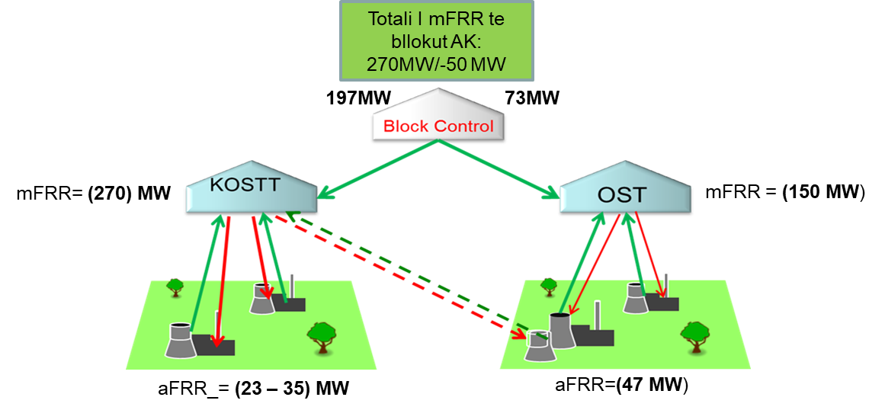

Figure 4. Activation of the manual reserve between the regulatory area and SP

In case of activation of the manual reserve through cross-border exchange with the purpose of reflecting the improvement of FRCE in the two respective regulatory areas from the moment of activation of the manual reserve until the moment of complete deactivation, the activated capacity must be entered in the respective AGC in SCADA/EMS systems of both TSOs. This is carried out through a Virtual Line made for this purpose or in other ways depending on the AGC system in the respective SCADA of the two TSOs. The activated energy will be recorded in the SCADA systems of the respective TSOs. This activated energy must be reported by the SCADA system to the respective TSOs and SP.

The operating scheme of the AGC in case of activation of the manual reserve is done according to the scheme fig.5:

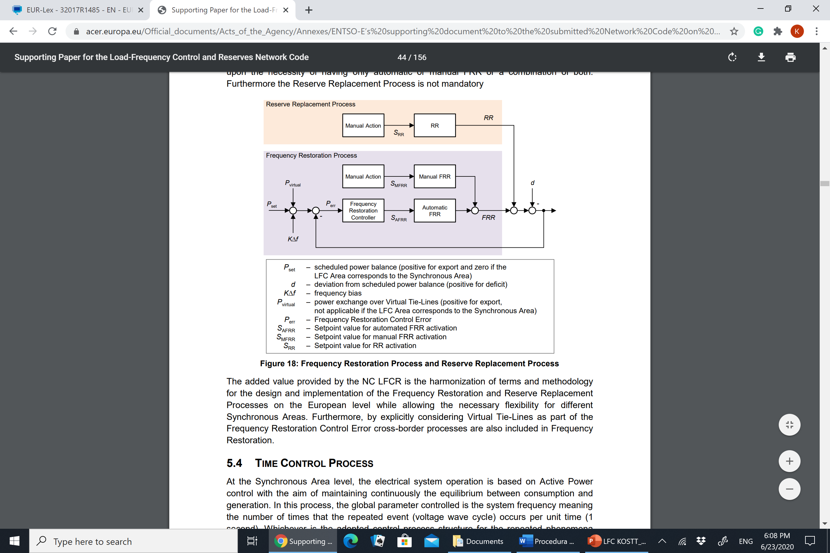

Figure 5. Frequency Restoration Process and Reserve Replacement Process

The correction of the FCRE value in the respective TSO control areas in case of activation of the manual reserve between cross-border TSOs is done in the Manual Action block as in fig.5.

**Example 5.** Let us assume the failure of an unit in the KOSTT regulatory area e.g. one block in TPP Kosova A, block A3 fails for example at 09:45, then KOSTT is in negative imbalance between -100 and -140MW. The working hours of the unit are until 12:00. During this period KOSTT will activate the reserve for aFRR balancing depending on the need for system balancing meaning there will be 3 reserve activations in this period with different capacities as in table 9:

|  |  |  |  |
| --- | --- | --- | --- |
| Settlement Period | Activation time | Capacity [MW] | Duration [min] |
| 10 | 09.45 – 10:00 | 120 | 15 |
| 11 | 10:00 – 10:15 | 120 | 15 |
| 11 | 10:15 – 10:45 | 140 | 30 |
| 11 | 10:45 – 11:00 | 100 | 15 |
| 12 | 11:00 – 12:00 | 100 | 60 |

Table 9

The process of balancing the KOSTT regulatory area will continue according to these steps:

* KOSTT will inform SP (KESH) that it has a contract for activation of capacity of 130 MW for a period of 15 min.
* KOSTT will inform the OST regarding the activation of the capacity of 130 MW for a time of 15 minutes and will receive the confirmation from the OST that the presented capacity can be technically activated.
* KOSTT and OST will confirm the free cross-border capacities that will be used for this activation of the aFRR reserve.
* After 3 minutes from the moment of notification SP (KESH) will confirm the activation of the reserve.

**Financial settlement of aFRR activation**

The financial settlement of aFRR activation will be made for the period of Settlement H defined by the rules in force.

Compensation for aFRR activation will be made on a monthly basis for available reserve capacity and compensation for committed energy. Capacity compensation is made according to the contract TSO - SP and has no activation effect except in case of failure.

Compensation for activated aFRR energy will be made on a monthly basis according to the contracted price:

**Upward regulation aFRR:**

The following diagram shows the activations of reserve during the Settlement period j=10, j=11 and j=12



$$P_{D_{aFRR_Up(j)}}=\sum_{n}{\frac{K_{A_{aFFR_Up(n)}}∙t_{(n)}}{60}}$$

The price of activated energy according to the contract: the price may have a reference price of any PX stock exchange (HUPEX, APEX)

${Price}_{P_{aFRR_{Up\left(j\right)}}}=1.35∙{PX}_{(j)}$

For the Settlement period j=10 the delivered Energy is:

$$P_{D_{aFRR_Up(10)}}=\frac{120∙15}{60}=30MWh$$

Price in PX: 55 €/MWh

$${Price}_{P_{aFRR_{Up\left(10\right)}}}=1.35∙55\frac{€}{MWh}$$

For the Settlement period j=11 the delivered Energy is:

$$P_{D_{aFRR_Up(11)}}=\frac{120∙15}{60}+\frac{140∙30}{60}+\frac{100∙15}{60}=125MWh$$

Price PX: 60 €/MWh

$${Price}_{P_{aFRR_{Up\left(11\right)}}}=1.35∙60\frac{€}{MWh}$$

For the Settlement period j=11 the delivered Energy is:

$$P_{D_{aFRR_Up(12)}_}=\frac{100∙60}{60}=100 MWh$$

Price in PX: 65 €/MWh

$${Price}_{P_{aFRR_{Up\left(12\right)}}}=1.35∙65\frac{€}{MWh}$$

The cost of activated energy for the Settlement periods 10,11,12 is:

$$P_{R{aFRR}_{Up}}=\sum_{j}{P_{D_{mFRR_{Up\left(j\right)}}}∙{Price}_{P_{mFRR_{Up\left(j\right)}}}=30MWh∙1.35∙55\frac{€}{MWh}+125MWh∙1.35∙60\frac{€}{MWh}+100MWh∙1.35∙65\frac{€}{MWh}=2227.5€+9315€+8775€=21127.5€}$$

1. **Full activation of the manual block reserve**

This way of activating the block reserve is done in case of falling of failure of the largest unit within the AK block. In this case both TSOs will activate the entire reserve of the AK block. The way of activating the reserve is combined so TSO-SP and TSO-TSO

The operation scheme of the aFRR is given in fig.5.

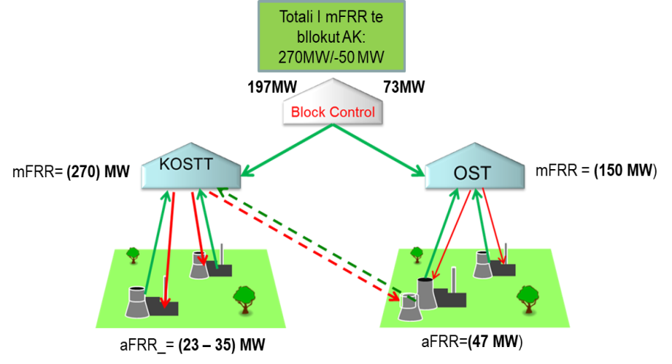

Figure 6. Combined activiation of the reserve TSO-SP and TSO-TSO

In case of activation of the manual reserve through cross-border exchange with the purpose of reflecting the improvement of FRCE in the two respective regulatory areas from the moment of activation of the manual reserve until the moment of complete deactivation, the capacity must be entered in the respective AGC in SCADA/EMS systems of both TSOs. This is carried out through a Virtual Line made for this purpose or in other ways depending on the AGC system in the respective SCADA of the two TSOs. The activated energy will be recorded in the SCADA systems of the respective TSOs. This activated energy must be reported by the SCADA system to the respective TSOs and SP.

The correction of the FCRE value in the respective TSO control areas in case of activation of the manual reserve between cross-border TSOs is done in the Manual Action block as in fig.5.

Table 10. lists the generating units that are ready to provide automatic and manual frequency restoration reserve.

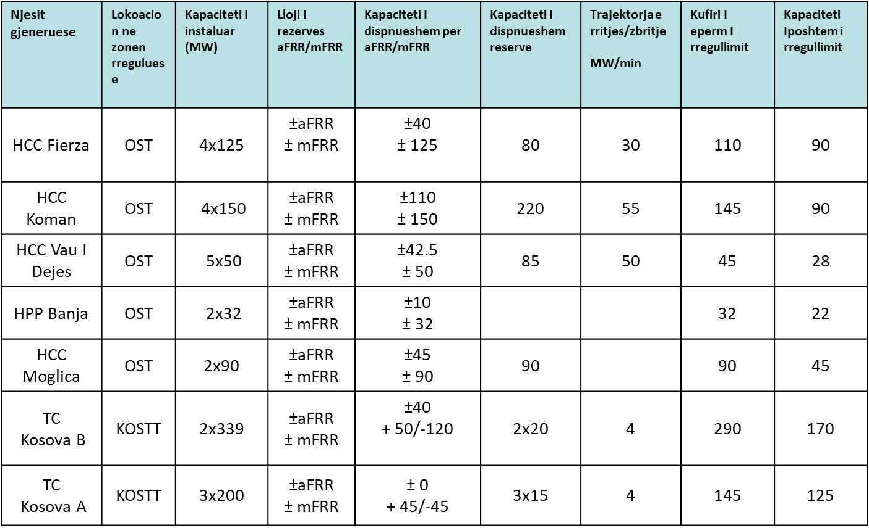

Table 10. List of generating units that can provide aFRR/aFRR regulatory reserve

**Example 6.** Let's assume the failure of a unit in the KOSTT regulatory area e.g. one block in TPP Kosova B, block B1 fails e.g. at 16:10, then KOSTT is in negative non-equilibrium of -270MW. Duration of the time out of operation is until 18:30 min.

The process of balancing the KOSTT regulatory area will continue according to these steps:

* KOSTT will inform SP (KESH) that it has a contract for activation of capacity of 197 MW for a period of 15 min.
* KOSTT requests the block (OST) the activation of the capacity of 73 MW. OST confirms activation of the 73 MW reserve.
* KOSTT will inform the OST regarding the activation of the capacity of 197 MW for a time of 15 minutes and will receive the confirmation from the OST that the presented capacity can be technically activated.
* KOSTT and OST will confirm the free cross-border capacities that will be used for this activation of the aFRR reserve.
* After 3 minutes from the moment of notification SP (KESH) will confirm the activation of the reserve.

**Financial settlement of aFRR activation**

Compensation for aFRR activated energy will be made on a monthly basis according to the contracted price and the TSO-TSO agreement.

1. For the upward regulation activated with the KOSTT - PS contract the final settlement is done as follows:

$$P_{D_{aFRR_Up(j)}}=\sum_{n}{\frac{K_{A_{aFFR_Up(n)}}∙t_{(n)}}{60}}$$

For the Settlement period j=17 (time interval: 16:10 - 17:00) The activated power is:

$$P_{D_{aFRR_{Up(17)}}}=\frac{197∙50}{60}=164.16 MWh$$

Price in PX: 55 €/MWh

For the Settlement period j = 18 (time interval: 17:00 - 18:00) The activated power is:

$$P_{D_{aFRR_Up(18)}}=\frac{197∙60}{60}=197 MWh$$

Price in PX: 60 €/MWh

$${Price}_{P_{aFRR_{Up\left(18\right)}}}=1.35∙60\frac{€}{MWh}$$

For the Settlement period j=19 (time interval: 18:00 - 18:30) The activated power is:

$$P_{D_{aFRR_Up(19)}}=\frac{197∙30}{60}=98.5 MWh$$

Price in PX: 65 €/MWh

$${Price}_{P_{aFRR_{Up\left(19\right)}}}=1.35∙65\frac{€}{MWh}$$

The cost of activated power that KOSTT has to pay to SP is:

$$P_{R_{aFRR_{Up}}}SP=\sum_{j}{P_{D_{aFRR_{Up\left(j\right)}}}∙{Price}_{P_{aFRR_{Up\left(j\right)}}}=164MWh∙55\frac{€}{MWh}∙1.35+197MWh∙60\frac{€}{MWh}∙1.35+98.5MWh∙65\frac{€}{MWh}∙1.35=36,789.75€}$$

1. For the Upward Regulation activated with the agreement TSO - TSO, (KOSTT - OST) The settlement is done as follows:

$$P_{D_{aFRR_Up(j)}}=\sum_{n}{\frac{K_{A_{aFFR_Up(n)}}∙t_{(n)}}{60}}$$

For the Settlement period j=17 (time interval: 16:10 - 17:00) The activated power is:

$$P_{D_{aFRR_Up(17)}}=\frac{73∙50}{60}=60.8 MWh$$

Price in PX: 55 €/MWh

For the Settlement period j=18 (time interval: 17:00 - 18:00) The activated power is:

$$P_{D_{aFRR_Up(18)}}=\frac{73∙60}{60}=73 MWh$$

Price in PX: 60 €/MWh

$${Price}_{P_{aFRR_{Up\left(18\right)}}}=1.2∙{PX}_{\left(18\right)}=1.2∙60\frac{€}{MWh}$$

For the Settlement period j=19 (time interval: 18:00 - 18:30) The activated power is:

$$E_{L_{mFRR_Ngritës(19)}}=\frac{73∙30}{60}=36.5 MWh$$

Price PX: 65 €/MWh

$${Price}_{P_{aFRR_{Up\left(19\right)}}}=1.2∙{PX}_{\left(19\right)}=1.2∙65\frac{€}{MWh}$$

The cost of activated power that KOSTT must pay to the OST is:

$$P_{R_{aFRR_{Up}}OST}==\sum_{j}{P_{D_{aFRR_{Up\left(j\right)}}}∙{Price}_{P_{aFRR_{Up\left(j\right)}}}=60.8MWh∙1.2∙55\frac{€}{MWh}+73MWh∙1.2∙60\frac{€}{MWh}+36.5MWh∙1.2∙65\frac{€}{MWh}=12,118€}$$

The total cost of activating the reserve in this time interval is:

$$P_{R_{aFRR_{Up}}}=P_{R_{aFRR_{Up}}SP}+P_{R_{aFRR_{Up}}OST}=$$

$$=36,789.75€+12,118€=48907.75 €$$

**IT requirements and data exchange:** In relation to IT requirements and data exchange, each OST within the AK block must create new electronic interfaces between the aFRR & RR platform and SCADA/EMS, as well as update existing electronic interfaces between SCADA/EMS and local controllers of the SP unit.

TSOs should enable the use of virtual cross-border lines in their SCADA/EMS systems as an addition to the physical cross-border lines currently used to calculate the Frequency Restoration Control Error (FRCE) within the AGC module of SCADA/EMS systems. For all virtual connection lines between OST, the corresponding EIC codes will be defined. Furthermore, the aFRR & RR platform in SCADA EMS should be able to generate and send the corresponding XML files for each TSO that will update the power exchange values ​​in each virtual line as a result of the activation operation process. The new values ​​of power exchange in the virtual connecting lines between the participating TSOs will be implemented in the AGC module in such a way as to match the proposed form of the standard aFRR & RR product under the conditions of the ascent and descent trajectory period. The interfaces between the SCADA/EMS of the TSOs and the SCADA systems of the local SP unit for activating the aFRR & RR balancing power must be updated to allow the sending of activation signals using standard protocols.

#### Exchange of information for the activation of the manual operation reserve

Rules for the exchange of information when activating the manual reserve between the two TSOs (KOSTT and OST) and TSO - SP (KOSTT-SP) are given in Chapter 9

The standard form for activation of the manual reserve is given in fig. 6

**Figure 7. Defining the standard balancing product**

In the case when the exchange of reserves within the AK block is done between the regulatory areas then the activation process has these characteristics:

* **The preparation period** is the time used for communication between the TSO requesting manual reserve service and the service provider and the TSO where the reserve is locked. The exchange of information is done in accordance with Chapter 9 of this procedure. During this time the TSO requesting the reserve receives confirmation of the capacity to be activated by the SP and confirmation regarding the security of the system from the TSO where the reserve is connected.
* **The trajectory of the activation of manual reserve:** is the time from the beginning of the activation of the manual reserve until the achievement of the maximum power declared for the reserve.
* **Full activation time** is the time of 15 min from the moment when TSO starts the process for activating the reserve until the moment when SP gives activation the full capacity declared for reserve. The full duration of activation should not exceed 15 min.
* **Minimum/maximum aFRR duration:** It is the time that the manual reserve is active with the declared maximum capacity.
* **Deactivation period:** is the time from the moment of starting the manual reserve deactivation until the moment when the aFRR value returns to the starting point before the activation of the reserve.

Since the whole process until full activation of the reserve must be performed within 15 minutes then the process of activation of the manual reserve (aFRR) for each step must be performed with this time duration:

* Preparation time: **2.5 min** (acceptable: 0-12.5 min)
* Activation period from the moment of starting the load increase: **[10 min]** (this period is also acceptable in the range 0-12.5min)
* Full activation time: **12.5 min** (according to EB <= 15 min)
* Duration: the minimum value of the duration for the case of direct activation of the activation of the manual reserve will be: **[5 min]** and the maximum value **[20 min]** (determined according to the BSP-TSO agreement)
* Deactivation time [**10 min]**

#### Maintaining FRCE parameters according to targets set for the block

The FRCE Level 1 and FRCE Level 2 values that define the FRCE deviation quality criteria vary according to the value of Factor K. The Level 1 and 2 values depend on the block size. The calculation of the values which serve as the target for the adjustment quality of each control block depends on the generation and load of the block. Target calculation is performed each year by the ENTSO-E working group known as the SFSG group.

If the value f calculated according to the criteria is greater than the defined target this may be an indication that:

* The LFC controller does not have the proper response speed;
* The activated amount of FRR is not enough;
* Available reserves are not sufficient;

The block monitor calculates the target parameters of the LFC zone in the AK block in accordance with the rules of the Synchronous Area of Continental Europe (SA CE), according to the following formulas:

$$\frac{{Level}_{1_TSOA}}{{Level }_{1AK}}=\sqrt{\frac{{FCR}_{i TSO_A}}{{FCR}_{i AK}}}$$

$$\frac{{Level}_{2_TSOA}}{{Level }_{2AK}}=\sqrt{\frac{{FCR}_{i TSO_A}}{{FCR}_{i AK}}}$$

Where:

- Level 1 of FCRE for TSO A

- Level 1 for AK block

- Level 2 of FCRE for TSO A

- Level 2 for AK block

- Initial obligation for Frequency Restoration (FRC) reserve for TSO A

- Initial obligation for frequency restoration reserve for for the AK block (sum of the initial obligations of all members of the LFC AK block).

The definition of FRCE Level 1 and Level 2 targets for the OST for 2019 is given in Table 12

|  |  |  |  |
| --- | --- | --- | --- |
|  |  | Starts from 1 January 2019 | |
| TSO | Coefficient Ci | Ppi  [MW] | Kri  [MW/Hz] |
| OST | 0.001398 | 4 | 38 |

Table 11

The determination of level 1 and 2 for Block AK is done as follows:

$${Level }_{1}=\left(\sqrt{K_{ri}}\right)∙\frac{K_{SA}∙r_{1}}{\left(\sqrt{K_{SA}}\right)}$$

$${Level }_{2}=\left(\sqrt{K_{ri}}\right)∙\frac{K_{SA}∙r_{2}}{\left(\sqrt{K_{SA}}\right)}$$

*K*SA – Total Factor K for Continental Europe

r1 - Constant coefficient for level 1 that has a value of r1 = 0.019596241

r2 - Constant coefficient for level 2 that has a value of r2 = 0.03705966

During 2019 the criteria 1 & 2 for the OST were:

|  |  |
| --- | --- |
| L1 [MW] | 20.01845891 |
| L2 [MW] | 37.85814306 |

**Table 1.**

The number of deviations within 15 minutes which have exceeded these criteria will be compared with the following values:

|  |  |
| --- | --- |
| Amount of 15 min intervals in 1 calendar year | 35040 |
| The amount allowed in 15 min intervals which are above Level 1 | 10512 |
| Amount allowed of 15 min intervals which are above Level 2 | 1752 |

**Table 2.**

In the case of AK Block which will consist of two LFC zones, after the calculation developed by the SFSG group for the whole block, an internal calculation will also be developed for the division of values according to quality criteria based on the mandatory quantity of the primary FCR reserve (Ppi) for each area.

#### Appendix 4 Scenarios in case of reserve depletion.

The scenarios of system operation and balancing of the AK Block in case of depletion of reserves are presented below:

**Scenario 1.** In case of failure of a generating unit (as the largest unit in AK), FCRE in the KOSTT regulatory area in that case will be -270 MW (negative).

From the contract of KOSTT with the balancing service provider will activate 197 MW with a contract between KOSTT - SP, as well as 73 MW from the OST (with its service provider). The full backup activation process must be completed within 15 min. This power will be taken from these service providers, but only for 4 hours max. Therefore in these cases, KOSTT as responsible for its Control Zone, must balance the system based on the Grid Code and SOGL, using these two options:

a) The representative of the generating unit dropped by SEE, which is causing the diversion, should find a solution and notify the TSO, which has provided the necessary energy and requests that this bid be activated according to the nominations as soon as possible but should not pass 4 hours from the failure of the unit.

b) If the representative of the generating unit dropped by SEE cannot provide the necessary energy then the TSO should, during the day, start the procedures for providing balancing power known as replacement reserve - RR.

**Scenario 2.** In case one of the generating units has been out of operation due to a sudden failure, and meanwhile the other largest generating unit in the block fails (Units B1 and B2 in TPP Kosova B), then in this case ACE of KOSTT can be up to - 520 MW (in case of failures of two generating units in TPP Kos B).

**Balancing scenarios**:

1. KOSTT will activate all available reserves, i.e. 197 MW through the agreement KOSTT - SP.
2. OST will activate the 73 MW reserve through the TSO-TSO agreement.
3. The KOSTT regulatory area and the control unit remain at an imbalance of -260 MW. KOSTT will make efforts to provide balancing energy that is available within the AK Block in order to reduce imbalances. The value of the reserve cannot be determined because it depends on the regulatory market circumstances between KOSTT and OST.
4. KOSTT will discuss system security with regional TSOs and if system security is not compromised, will deviate briefly until securing the power import contract. The maximum deviation time will be 2 hours.
5. In case options c) and d) fail and the deviation continues then as a last resort the load will be disconnected respecting the load disconnection compensation according to the balancing mechanism.
6. In case the safety of the system is violated at the moment of the fall of the two generating units from the system then the disconnection of the load will be applied immediately. The load disconnection value will be estimated as appropriate and the same should be minimal.
7. TSO in cooperation with market parties (KESCO, KEDS, etc.) will build adequate load disconnection schemes which will be applied in case the load disconnection is achieved. The purpose of the schemes is to protect consumers vital to the operation of the system and reduce the cost of disconnection to consumers.