METhodology ero/No. XX/2020

METHODOLOGY ON CALCULATION OF REFERENCE PRICE FOR ENERGY GENERATED FROM RES

September, 2020
Pristina
Table of Contents

CHAPTER I GENERAL PROVISIONS 3
Article 1 Purpose and Scope 3
Article 2 Definitions and Interpretations 3
Article 3 Context 4
Article 4 Principles and Conceptual Understanding 4
CHAPTER II Methodology on calculation of hourly reference price 7
Article 5 The method of calculation 7
CHAPTER III TRANSITIONAL AND FINAL PROVISIONS 8
Article 6 Amendment 8
Article 7 Interpretation 8
Article 8 Entry into force 8

The Board of Energy Regulatory Office, in line with the authority vested under Article 9, paragraph 1, subparagraph 1.7, Article 15, Article 26 and Article 47 of the Law on Energy Regulator No. 03/L-185, in the session held on 30.09.2020, approved the following:

METHODOLOGY ON CALCULATION OF REFERENCE PRICE FOR ENERGY GENERATED FROM RENEWABLE SOURCES

CHAPTER I
GENERAL PROVISIONS

Article 1
Purpose and Scope
  - This methodology defines the method of determining the reference price for energy generated from renewable energy sources (RES). This price will be applied by the Market Operator for the energy sold to the Suppliers. It will also apply to the sale and purchase of energy from RES according to the regulated framework.
  - This Methodology sets out:
    - Basic principles according to which the reference price will be calculated; and,
    - Method for calculation of reference price;

Article 2
Definitions and Interpretations
  - The terms used in this methodology have the following meaning:
    - “Renewable Energy Sources (RES)” – renewable non-fossil energy sources, such as: wind energy, solar energy, geothermal waters, wave energy, hydro energy, biomass, waste landfill gas, wastewater treatment gas, biogas, as determined in the applicable legislation for renewable energy sources;
    - “Reference Price” –It is calculated using an avoided cost methodology and an inverse merit order ranking based on the most expensive production first and the least expensive production last.
    - “Wholesale customer (trader)” - natural or legal person who purchases electricity for the purpose of resale inside or outside the system in which it is established;
    - “Universal Service Supplier (USS)” –is the supplier to whom a public service obligation has been imposed by the regulator to provide universal service under regulated criteria for household and non-household customers who have an annual turnover of not more than ten (10) million euros or not more than fifty (50 ) workers.
    - “Universal Service Customer (USC)” - means a customer who is entitled the universal service, in line with the meaning of Article 37.2 of the Law on Electricity.
    - “Import Prices”— prices for imports supplying to all customers currently determined by the Hungarian Power Exchange but eventually by the Albanian Power Exchange.
  - Other terms used in this document will have the same meaning as in the Law on Energy Regulator, Law on Electricity and Law on Energy.

Article 3
Context
  - In general, the main sources that contribute to the electricity supply in Kosovo are:
    - Domestic generation contracted to be offered for supply to USS customers;
    - Domestic generation contracted to be offered for supply to non-USS customers;
    - Energy import;
    - Domestic generation from RES which is another form of energy sale in addition to the support scheme, but is not included in the calculation of the reference price.
  - The reference price is the avoided cost of the electricity load replaced by RES based on the merit order i.e. the avoided most expensive electricity generation that is replaced by RES.
  - Calculation of reference price therefore requires information related to:
    - The volume of RES generation;
    - The merit order assuming no RES generation; and
    - The price of energy that would be displaced;

Article 4
Principles and conceptual understanding
1. The reference price can be calculated for any time period i.e. it could be calculated on an hourly, quarterly or annual basis. For the purpose of this methodology, the price calculated on annual basis is applied.
2. The volume of displaced load is based on the merit order of the load with the most expensive generation source replaced first and the least expensive source replaced last.
3. The reference price per hour would be based on the volume of RES generation and the cost of the alternatives avoided at the time for that volume. The price may be determined by displacing the load of multiple generators. Therefore, if the RES generation was 5 GWh and the most expensive avoided generator produced 2 GWh, an additional 3 GWh from the next most expensive source would also be displaced. Therefore, the avoidance of the 5 GWh of RES generation would be based on the weighted prices and volumes from different generators. The same principle would apply over multiple generators or a single generator.
4. The calculation of an annual reference price is based on the current values of the displaced electricity sources per hour for the entire year and dividing it by the expected volume of RES generation per hour for the entire year.
5. The costs of generation vary by the different sources:
5.1 The cost of imports is determined by market prices on the Hungarian Power Exchange less the cost of transmission rights that must be acquired. Once the Albanian Power Exchange is launched, which will also function as the Kosovo Power Exchange, it will indicate future market prices for imports.
5.2 The cost of wholesale energy for supply of customers who are entitled the Universal Service;
5.3 The cost of wholesale energy for non-USS customers (deregulated);
5.4 RES generation wholesale cost in the support scheme and regulated framework are not included in the reference price calculation and have no relevance to the reference price (as the definition notes it is based on the price of the avoided load from other generation sources).
6. Figure 1 below illustrates what a merit order used to calculate the reference price for Kosovo is likely to look like. It will change across the annual load curve depending on the generating source. The figure also provides hypothetical RES generation.
7. From Figure 1, we can see three main phases:
7.1 A: the reference price is determined by import costs.
7.2 B: the reference price is determined by the wholesale price of electricity sold to non-USS customers and import.
7.3 C: The reference price is determined by the wholesale price for non-USS customers, but may also be based on the wholesale energy prices for customers who are entitled the Universal Service (USS)
Figure 1 Analysis of reference price across the annual hourly load curve
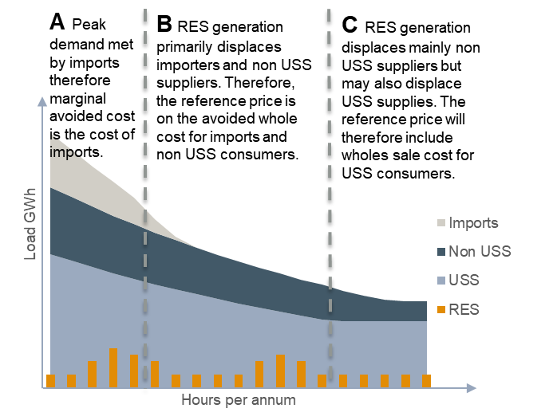

8 It is important to note the following conceptual complexities:
8.1 . Forecast RES generation volumes could change during the year due to seasonality (or time of day factors in the case of solar or wind) or due to new RES plants being commissioned during the year.
8.2 Wholesale energy prices for non-USS customers can be based on profit maximization, consequently the relevant generators can apply the maximum possible prices. In the context of Kosovo, it could be the alternative customer where the generator can sell, for which the price would be determined by reliable Energy Exchanges (such as the Hungarian Stock Exchange, the Albanian Stock Exchange, etc.).

CHAPTER II
METHODOLOGY ON CALCULATION OF HOURLY REFERENCE PRICE

Article 5
The method of calculation

1. Based on the concepts and principles outlined above, an equation has been created to calculate the reference price as follows:

$$G_{g,h}=minimum\left({energy source}_{g,h},{Residual RES}_{g,h}\right)$$
$${Residual RES}_{g,h}=G_{g-1,h}$$
$${Residual RES}_{0,h}={BRE}_{h}$$
$$X_{g,h}=G_{g,h}×{Price}_{g,h}$$
$$Reference price \text{=}\frac{\sum_{\text{h=1}}^{\text{8760}}{\sum_{\text{g=1}}^{\text{n}}{{\text{X}}_{g,h}}}}{\sum_{h=1}^{8760}{{RES}_{h}}}$$
where:
h in an hour in the current year;
g is the electricity source (imports, wholesale energy prices for USS customers and non-USS customers);
n is the number of electricity sources in the calculation;
RES_{h} is the current volume of RES generation forecast to be sold by the MO in hour h;
Residual RES_{g,h} is the volume of RES generation still available to displace generation source g after displacing generation source
g-1 in hour h;
G_{g,h} is the variable denoting the volume of a generation source g displaced by RES in hour h;
Price_{,g,h} is the forecast value per MWh of generation source g displaced by RES in hour h;
X_{g,h} is the value of generation source g displaced by RES in hour h;

CHAPTER III
TRANSITIONAL AND FINAL PROVISIONS

Article 6
Amendment
- The Regulator is entitled to amend or modify any provision of this methodology.
- The procedures for modification or amendment of this Methodology shall be the same as for its approval.

Article 7
Interpretation
In case there are uncertainties regarding the provisions of this methodology, the Board shall issue explanatory information.

Article 8
Entry into force
This Methodology shall enter into force on the date of approval by the Board of the Regulator and will be published on the official website of the Regulator,

The Board of Energy Regulatory Office:

______________________
Arsim Janova, Acting-Chairman

______________________
Besim Sejfijaj, Member

______________________
Selman Hoti, Member

______________________
Izet Rushiti, Member

